Machine Vision Pipeline for Steel Surface Defects Detection using FPGA SoC
Funding Required: Rs. 116,000

Proposal submitted in connection with the
NEDAASC FYP Funding 2024-25

Batch: 2021
Aaliyan Mansoor (CS-21146)
Muhammad Maaz Khan (CS-21019)
Mohib ud Din (CS-21142)
Muhammad Babar Ali (CS-21145)

Project Advisor
Ms. Fakhra Aftab, Dr. Majida Kazmi
Department of Computer & Information Systems Engineering

Abstract/Summary
Our project aims to develop an FPGA-based machine vision system for detecting surface defects on steel rods and hot rolled steel strips, commonly used in automotive, aerospace, and manufacturing industries. Traditional inspection methods, including manual checks and conventional automated systems, often lack the real-time speed and accuracy needed for high-demand production, while GPUs, though faster, consume high power. By deploying a deep learning model on an FPGA, we aim to achieve real-time, low-power, and accurate defect detection, improving product quality and reducing operational costs. The solution will enhance manufacturing efficiency aligning with industry standards.
In collaboration with DreamBig Semi-Conductors and Agriautos, we seek to bridge the gap between academic research and industrial application by creating a system that enhances productivity and reduces waste in steel processing plants. Funding will enable us to acquire FPGA development boards, high-resolution cameras, testing materials, etc. necessary to build and validate this solution.

Project Synopsis
Background
Steel surfaces, such as steel rods and hot rolled steel strips, are essentially used in automotive, aerospace, and construction industries. However, these surfaces are prone to various defects—dents, scratches, cracks, and more—that compromise product quality and pose operational risks. Traditional defect detection methods, relying on manual inspection or conventional automation, are often too slow or inaccurate for modern production environments. Deep learning-based machine vision offers a promising solution, but deploying these models on CPUs or GPUs can be inefficient in terms of speed and power consumption.
Aims and Objectives
- Develop a machine vision system using FPGA for real-time steel surface defect detection.
- Train and optimize a deep learning model to accurately identify defects such as scratches, cracks, dents, etc.
- Deploy the optimized deep learning model on the FPGA development board to achieve accurate defect detection with faster response times and lower power consumption.
- Evaluate and compare performance metrics of the FPGA accelerated model and traditional CPU/GPU based implementation.
- Provide a solution which aligns with industry standards.

Flowchart
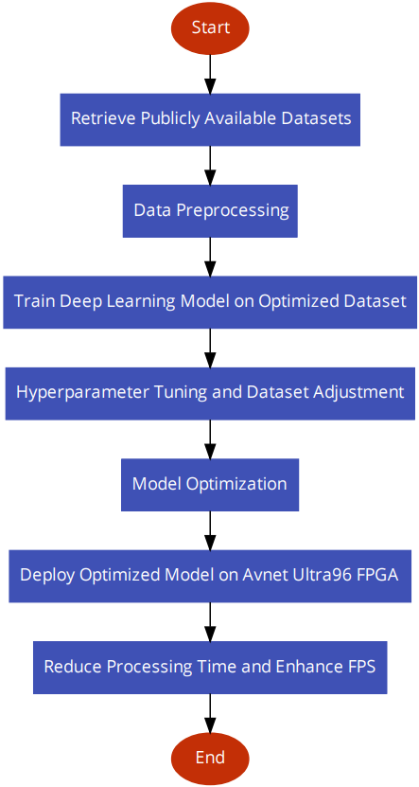

Significance
Our project addresses the critical need for real-time, accurate, and energy-efficient defect detection in steel production. By leveraging FPGA technology, the solution will enhance operational efficiency, improve product quality, reduce material waste, and lower production costs. It aligns with industry demands for real-time processing and sustainability in high-demand manufacturing environments.

Materials
- Avnet Ultra96 FPGA development board,
- SSDs for storage and execution of FPGA development software and storage of dataset and deep learning models,
- Custom steel surface defect dataset.
Methodology
Utilizing custom datasets, perform necessary data preprocessing, train a deep learning model on the optimized dataset to detect certain types of defects on steel surfaces.
Optimizing the model by performing hyperparameter tuning, further adjusting the dataset, and performing other necessary operations to improve the performance of the model.
Deploying the optimized model on an Avnet Ultra96 Field Programmable Gate Array (FPGA) development board, aiming to significantly reduce processing time, enhance frames per second (FPS) and improve the overall performance of the optimized deep learning model.
SDGs
☐ No Poverty | ☐ Zero Hunger
☐ Good Health and Well-Being | ☐Quality Education
☐ Gender Equality | ☐ Clean water and Sanitation
☐ Affordable and Clean Energy | ☒ Decent Work and Economic growth
☒ Industry, Innovations and Infrastructure | ☐ Reduced Inequalities
☐ Sustainable Cities and Communities | ☐ Responsible Consumption and Production
☐ Climate action | ☐ Life Below Water
☐ Life on Land | ☐ Peace, Justice and Strong Institutions
☒ Partnerships

Cost Breakdown
List the items and their description (if needed). Add or delete the rows accordingly.
S.No | Items/Testing/Service etc. | Amount in Rupees
1 | Solid State Drives (SSD) | 33,000
2 | Avnet Ultra96-V2 Zynq UltraScale+ ZU3EG Development Board | 83,000
3
 | TOTAL AMOUNT | Rs. 116,000
Proposal should not be more than 3 pages excluding the title page.
Please change the name of word file in accordance with the project advisor name as
“Dr. AAA BBB CCC – NFYP Proposal 2025”

